MAHATMA EDUCATION SOCIETY’S

PILLAI COLLEGE OF ARTS, COMMERCE & SCIENCE
(Autonomous)

NEW PANVEL

PROJECT REPORT
ON
“Amazon Products Ratings and Review Report Dashboard”

IN PARTIAL FULFILLMENT OF MASTER OF DATA ANALYTICS
SEMESTER II – 2024-25

PROJECT GUIDE:
Omkar Sherkhane

SUBMITTED BY:
Kshitiz Varunkumar Tiwari

ROLL NO:
10338

Mahatma Education Society's
PILLAI COLLEGE OF ARTS,COMMERCE & SCIENCE
(Autonomous)
Re-accredited “A” Grade by NAAC (3rd Cycle)



Project Completion Certificate

THIS IS TO CERTIFY THAT

Kshitiz Varunkumar Tiwari

of M.Sc. Data Analytics Part - I has completed the project titled “Amazon Products Ratings and Review Report Dashboard” of subject “Big Data Analytics” under our guidance and supervision during the academic year 2024-25

Project Guide | Course  Coordinator | Head of the  Department

Introduction
The Amazon Products Ratings and Review Report Dashboard in Power BI is designed to analyze and visualize customer feedback and pricing data across various product categories. It provides insights into customer satisfaction, pricing trends, and discount analysis by displaying key metrics such as average ratings, review counts, actual vs. discounted prices, and category-wise performance.

Objectives
- To provide an overview of customer ratings and reviews across various product categories.
- To analyze trends in ratings, reviews, and pricing distribution.
- To identify top-rated and most discounted product categories.
- To assist in decision-making based on customer sentiment and pricing insights.

Data Sources
- Amazon Product Review and Pricing Dataset (CSV)
- Fields Used:
  - Product ID
  - Product Name
  - Category
  - Average Rating
  - Review Count
  - Actual Price
  - Discounted Price
  - Discount Percentage

Dashboard Components

1. Key Metrics Panel
- Average Actual Price: Displays the mean actual price of products.
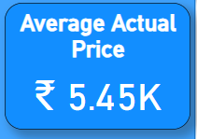
- Average Discounted Price: Shows the mean discounted price.
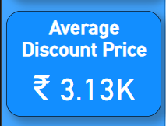
- Average Rating: Represents the overall rating of products.
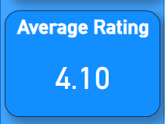
- Number of Categories: Indicates the total number of product categories.
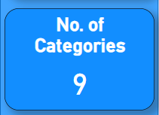

2. Visualizations
- Actual Price by Category: A line chart representing the total actual price distribution across categories.
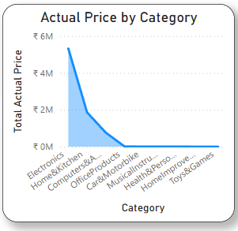
- Discounted Price by Category: A similar line chart displaying the total discounted price by category.
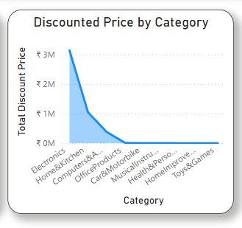
- Discount % of Price by Category: A stacked bar chart showing the percentage discount across different categories.
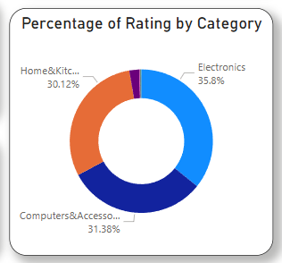
- Actual Price vs Discount Price Total: A bar chart comparing total actual price vs. total discount price.
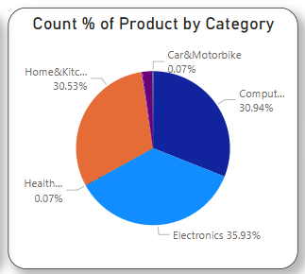
- Percentage of Rating by Category: A donut chart displaying the distribution of ratings across different categories.
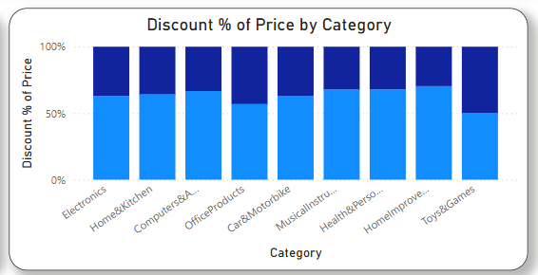
- Count % of Product by Category: A pie chart showing the percentage of products in each category.
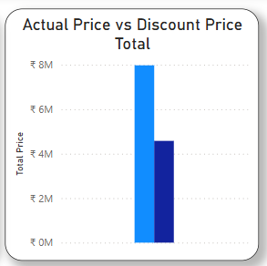
- Average Discounted Price by Category: A horizontal bar chart visualizing the average discounted price per category.
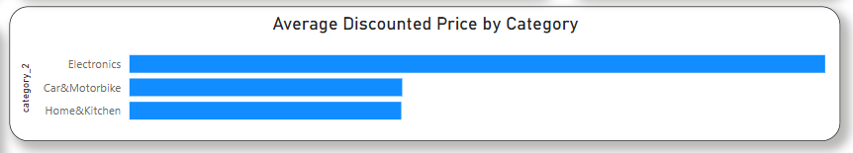
- Average Rating Count by Category: A bar chart displaying the number of ratings for each product category.
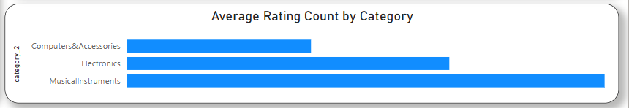

3. Final Dashboard
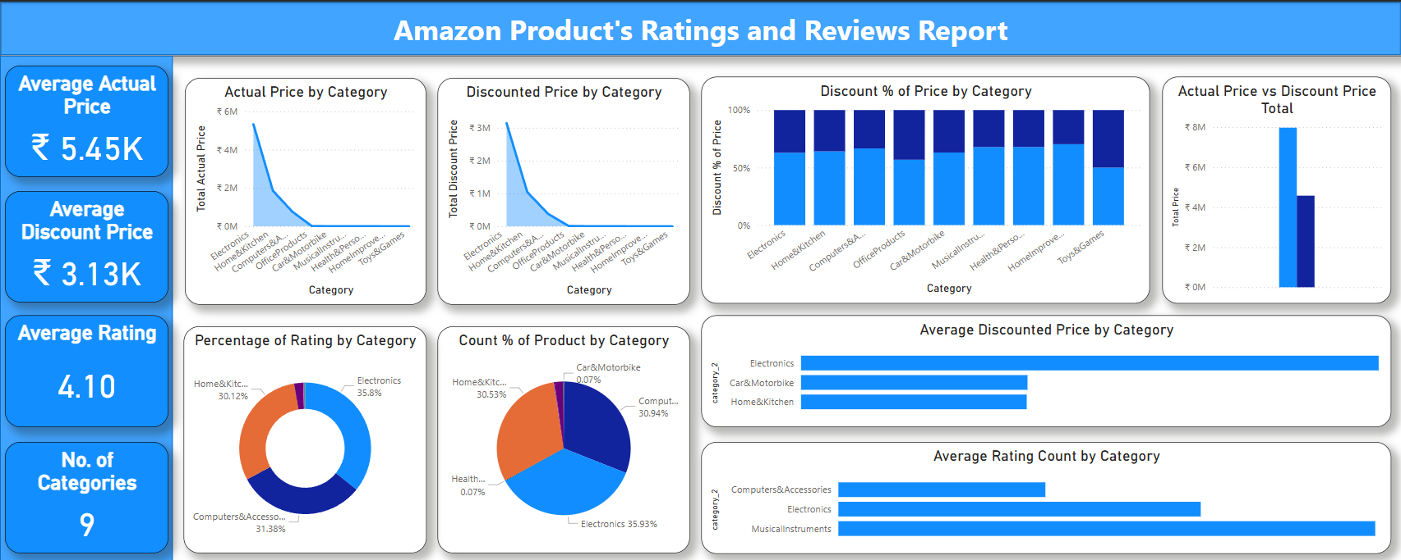

Power BI Implementation Steps
- Data Import: Load the dataset into Power BI.
- Data Cleaning & Transformation: Remove duplicates, handle missing values, and categorize data as needed.
- DAX Measures: Create calculated measures such as average rating per category, total discount price, and percentage discount.
- Visualizations: Add and customize charts (bar, line, pie, etc.) for better insights.
- Filtering & Slicing: Implement interactive filters to allow users to analyze specific product categories or time periods.
- Dashboard Formatting: Apply appropriate colors, labels, and formatting for clarity.

Key Insights & Business Impact
- Identifies high-performing product categories to focus on for marketing.
- Highlights underperforming categories that may need improvement.
- Enables trend tracking to understand seasonal rating patterns and pricing changes.
- Provides customer sentiment insights for enhancing product quality and customer service.
- Assists in discount strategy planning by analyzing actual vs. discounted price trends.

Conclusion
This Power BI dashboard effectively visualizes Amazon product ratings, reviews, and pricing insights, aiding in strategic decision-making for businesses. It helps in identifying strengths and weaknesses across different categories, ensuring data-driven improvements.

